Walk 2 Woonton to Almeley
Last walked in January 2019

Description. An 8 km (5 mile) easy walk with no hills.
Start. By telephone box in Woonton. Explorer Map 201 Grid 353523.
Directions from Whitecross roundabout (Turn milometer to zero). Take the A438 to Brecon and after 1½ miles TR onto the A480 to Creden Hill. Cross over a roundabout then traffic lights at Creden Hill and on towards Kington. At approximately 10.9 miles stop at the Leominster/Brecon road junction where you TL, and immediately TR signed Kington 7. At 12.6 miles you reach Woonton. TL sign for Almeley 1½, take the first right and park up near to the telephone box.

1. Woonton. Woonton is a hamlet about 1 mile from the disused railway station at Almeley, this station was on the Kington and Eardisley line. The name of Woonton is Anglo Saxon and means, ‘the dweller at the farm by the wood’ (Wod-tun). The Religious Society of Friends have a meeting house in this village. Go back up the road from the telephone box and cross the main road ahead onto a Public Footpath, ‘Friends Meeting House 1888’, (Chapel Stile Cottage) is on your R. Walk to the end of the wide footpath and go thru a kissing gate (R) into F1. Keep to the R edge of this large field. Go thru a gap in the hedge into F2 and continue along the R field edge. At the field end you TR and go thru a kissing gate and continue along an enclosed track. Pass stables and house on your R and follow a wide track/drive to meet a road where you TL. As the road bends L you continue straight on down a ‘No Thru Road.

2. No Thru Road. Continue along the ‘No Thru Road’ and when the road bends L, by a footpath sign, TR, go thru a gate and along an enclosed track, (the track may be a little overgrown the further along you go). When the lane peters out, continue in the same direction by walking a short distance along the edge of the field on your L. At the end of the field you TL and continue along the field edge for about 25 paces, then TR into the tree line and go down some hidden steps. Cross over a footbridge and continue up F3, passing a lone oak tree to reach a stile by gates. Cross over the stile into F4 and continue along the L edge to go thru gates and along an enclosed track. Go thru a gate into F5 and continue along the top R edge. At the end of the field TR and cross over a couple of stiles, into F6. Continue on up, keeping a hedge on your L to cross over a styled footbridge into F7. Keep to L field edge and go over a stile/metal gate onto a road.

3. St Mary’s Church. TL and walk along the road to a road junction, (straight in front of you is Alemely Church, St Mary). Cross the road ahead, go thru the small church gates and follow the path that goes past the main entrance and around the L hand side of the church. It is not known how long there has been a Christian church on this site, apart from some re-used arch stones above the doors, which are of an earlier date, the oldest part of the church is the base of the West Tower, which was built about 1200. Beside the church of Almeley is a grass-grown mound upon the keep of a medieval castle once stood. The whole site of the ancient castle is now under pasture. Neither the Doomsday Survey nor the earliest list of border fortifications make any mention of an ancient castle on this site and no evidence exists as to when Almeley Castle was built. Continue on the path to a small metal gate and onto a road where you TL. Continue down the road to reach a stone track/drive on your R, going to ‘The Batch Cottage’, this track/drive appears just before the road goes over a stream.

4. Batch Cottage Drive. TR, walk along the R hand side of the stream along Batch Cottage Drive, which is a Public Footpath. On reaching a garage yard, take a couple of steps to the R and continue in the same direction, walking along an enclosed path that’s to the R of a garage, and after a short distance goes thru a kissing gate and across a concrete footbridge. Follow the woodland path, the stream is now on your R. 60m further on, just before reaching a wooden seat, bear R onto the lower path. Upper path gets overgrown. Cross a wooden footbridge and continue on the main path, keeping the stream on your R and ignoring any bridges that cross the stream. Pass a black and white cottage, then pass ‘House at Pooh Corner and continue on up until you reach a main road. TR onto a road and go thru Almeley Wootton, ignore the road going off to the L. Go passed a red phone box (L) to reach a road junction where you TR, (The Friends Meeting House is on your R).
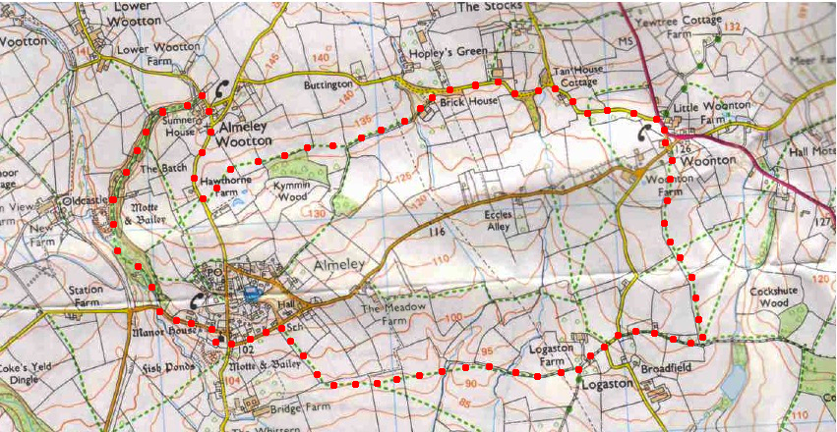
5. Almeley. Continue along the road towards Almeley. Almeley is mentioned as a small village in the Doomsday Book of 1086. Almeley had a railway station on the line from Kington to Eardisley, the station building, (which is used as a cattle shed), and the platform still exist. Pass a Public Footpath sign on the R, and a few meters further along, on the L is another Public Footpath sign, (about 100m from a house) where you TL and cross over a stile into F8. Bear slightly L as you cross this field to cross over a stile by a metal gate into F9. Follow the overhead cables to cross a stile that’s near to the corner of a wood into F10. Follow the overhead cables; the wood is on your R, to cross another stile into F11. Continue across the next field and in the field corner you cross over one stile, then immediately TR to cross over another stile and onto a tarmac lane, where you TL.
1
2
3
4
5
6

6. Brick House Farm. Continue along the lane to reach ‘Brick House Farm on the R. The lane veers L, you keep straight ahead and cross over some grassland to join a narrow road where you TR. Continue along the road for about 1 km to reach the main road where you TR. A short distance further on you TR to reach the start point at red phone box.
1
2
3

